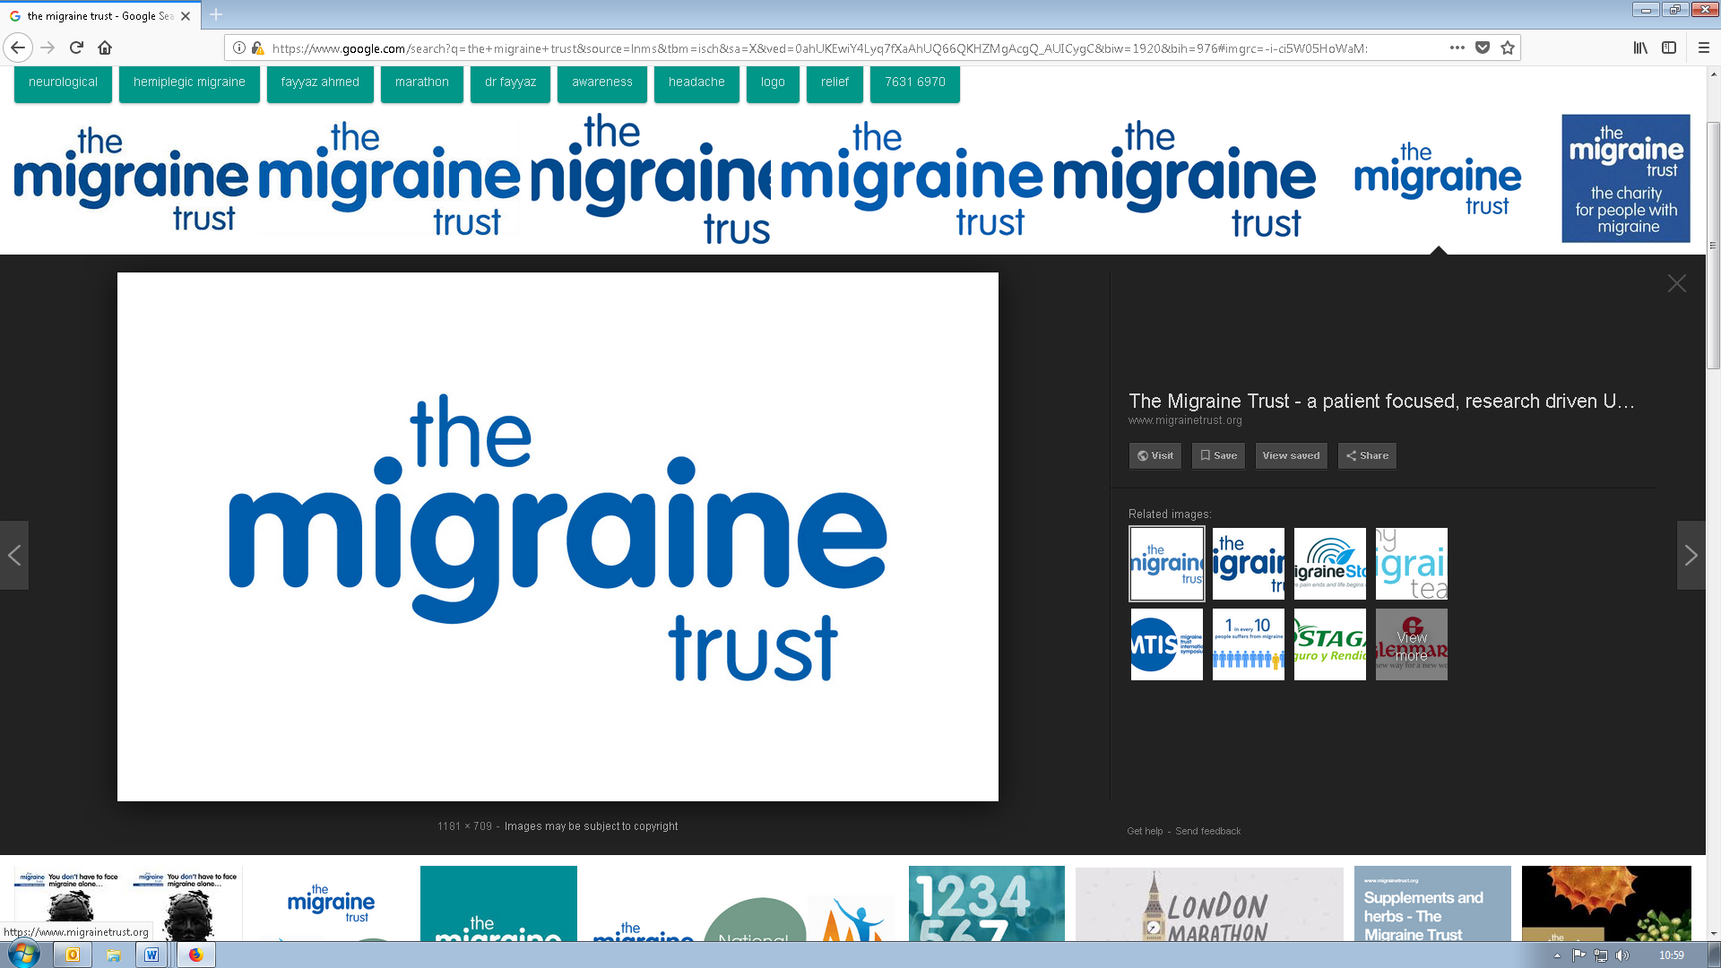

**Letter to local representative template**

|  |
| --- |
| **How you can use this letter**  With one in seven people in the UK living with migraine, your local representative (MP, MSP for Scotland, AM for Wales, and MLA for Northern Ireland) will have many constituents whose lives are severely impacted by migraine and who are struggling to navigate the healthcare system. It is important that they are made aware of the issues in migraine healthcare in the UK, and what needs to improve. It is also crucial that they know how they can help remedy them.   As their constituent and potential voter, you are in an important position to inform them of these issues, and to ask for their help and to make them aware of The Migraine Trust. Here is a template letter that you can use to do just that.  **How to contact them**  You can find out who your MP, MSP, AM or MLA is, and all their contact details below:   * For MPs: [findyourmp.parliament.uk](http://findyourmp.parliament.uk) * For MSPs (Scotland): [parliament.scot/msps.aspx](http://parliament.scot/msps.aspx) * For AMs (Wales): [assembly.wales/en/memhome/Pages/memhome.aspx](http://assembly.wales/en/memhome/Pages/memhome.aspx) * For MLAs (Northern Ireland): [niassembly.gov.uk/your-mlas/](http://niassembly.gov.uk/your-mlas/)   If you do write, thank you. We’d like to know if they respond as we may be able to follow up with them. You can email us at [press@migrainetrust.org](mailto:press@migrainetrust.org) or post a copy to us at The Migraine Trust, 4th Floor Mitre House, 44-46 Fleet Street, London EC4Y 1BN. |

**Template letter**

[Your full address]

[Date]

Dear [local representative name],

I live in [constituency name] and I am writing to you because I wanted to make you aware of the problems in migraine healthcare across the UK and to ask for you to support better care.

[If you are happy to, add details of your experience of migraine including how it impacts your life and any issues with care that you have experienced]

Migraine is a severe and painful long-term health condition that one in seven people live with - that’s 10 million across the UK. There are therefore a great many people in your constituency who will be living with it, but not getting the support and care they need. People with the condition experience migraine attacks, which are a whole-body experience. It is not only a very painful condition, but is also usually disabling - people are often unable to function normally when they are having a migraine attack. This has very serious consequences for many parts of their lives, from their working to family life.

It is therefore crucial that people living with migraine receive the right and most effective healthcare, and you can help ensure that they do.

**What needs to change**

The Migraine Trust, the UK’s leading migraine charity, has just launched [a new report, ‘*Dismissed for too long*’](https://migrainetrust.org/wp-content/uploads/2021/09/Dismissed-for-too-long_Recommendations-to-improve-migraine-care-in-the-UK.pdf)**,** which highlights a range of inequities around migraine and makes recommendations calling for positive change.

The report highlights key areas for improvement for migraine patients from quicker diagnosis to access to new medication. A particular problem is that many people who are eligible for the new calcitonin gene-related peptide (CGRP) antibody migraine medication, the first ever drugs developed to prevent migraine, have struggled to access it over the last year. This is despite it now being approved for use on the NHS.

The charity is calling for migraine to be recognised as having a significant impact and cost on people’s lives, as well as on the economy and NHS, and for local leadership in reviewing and meeting the migraine needs in every area.

**How you can help**

I support The Migraine Trust’s campaign, and ask that you do too. Not just for the thousands of your constituents who are affected by migraine, but everyone in the UK that is living with this painful and debilitating condition.

I would be grateful if you could consider showing your support for people who live with migraine by:

* Supporting #BetterMigraineCare on social media;
* Writing to the Minister for Prevention, Public Health and Primary Care to highlight the report and ask what the Department of Health and Social Care is doing to support improvements;
* Contacting our local NHS leadership to find out what they are doing to review and plan migraine care to meet local needs.

Thank you for your time. I look forward to hearing from you.

Yours sincerely,

[Your name]

[Your address]